January 21-23, 2022 Level 1-10 & XCEL

Meet Site: Texas Dynamix Entry Fees: $130 Level 3-10
1901 Preston Park, Blvd $110 Level 1,2, XCEL
Plano, TX 75093 $45 TEAM ENTRY

Leotard is included with Entry!!
Include Leotard Sizes on Meet Entry Form!

Mail Entries to: Entry Deadline with Leotard:
Texas Dynamix Gymnastics NOVEMBER 30, 2022
1901 Preston Park Blvd **ENTRIES WILL BE
Plano, TX 75093 ACCEPTED AFTER
11/30 BUT WILL
NOT RECEIVE LEO

SCHEDULE WILL BE AWARDS:
POSTED BY: DEC 20TH CUSTOM TEAM FORMAT: MODIFIED AWARDS & SPECIAL
TRADITIONAL ALL-AROUND
AWARDS!

Meet Director: Tabitha Valdez – Tabi.Valdez@gmail.com
Host Meet Hotel: Homewood Suites by Hilton North Dallas/Plano
FUN THINGS TO DO IN THE AREA!

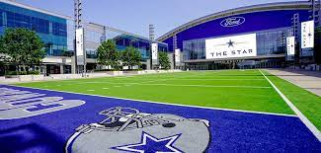
The Star in Frisco

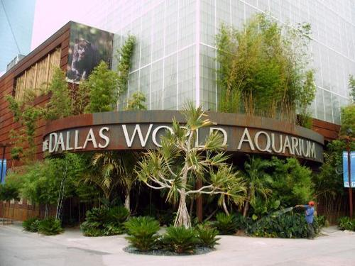
Dallas World Aquarium

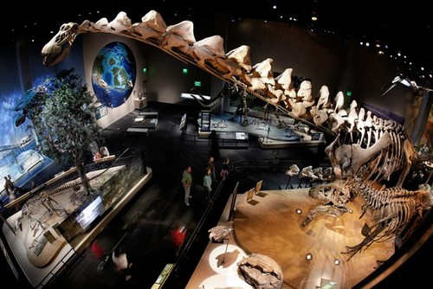
Perot Museum

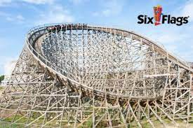
Six Flags over Texas

